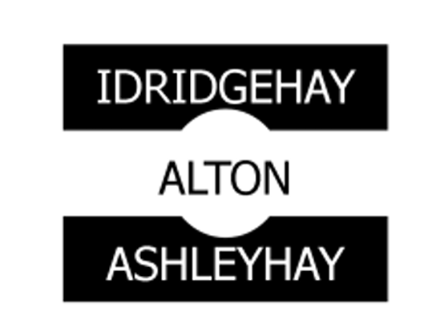

COUNCIL MEETING
SUMMONS

You are hereby summoned to attend
a meeting of Idridgehay & Alton and Ashleyhay Parish Council
to be held on
Wednesday 24th September 2025
at 7:00PM
at St. James’ Church, Idridgehay
for the purpose of transacting
the business on the agenda.

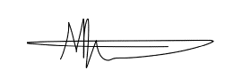

287 Portland Rd,
Mansfield, NG20 9EZ
M. Evans
Clerk (Proper Officer) & RFO

DATED: FRIDAY 12th September 2025
IDRIDGEHAY & ALTON AND ASHLEYHAY PARISH COUNCIL
ORDINARY MEETING COUNCIL MEETING
NOTICE & AGENDA
Dated: Friday 12th September 2025
Pursuant to Schedule 12 of the Local Government Act 1972 notice is hereby given that the next meeting of Idridgehay & Alton and Ashleyhay Parish Council is to be held at St James’ Church, Idridgehay on Wednesday, 24th September 2025, at 7:00PM

Matthew Evans | Clerk & Responsible Financial Officer
Idridgehay & Alton and Ashleyhay Parish Council

AGENDA
IAAP – 32/25 | To receive apologies of absence.
IAAP – 33/25 | To receive any Declarations of Interest.
IAAP – 34/25 | To approve the minutes of the Parish Council meeting held on Wednesday, 14th May 2025, Tuesday 24th June 2025 and Wednesday 9th July 2025.
IAAP – 35/25 | Questions from members of the public:  To allow a fifteen-minute open forum (if required) for any members of the public to speak on matters affecting the Parish in accordance with section 3f. of the Council’s standing orders.  Members declaring a Disclosable Pecuniary Interest who wish to make representations or give evidence under the Code of Conduct relating to the agenda items shall do so at this stage.
IAAP – 36/25  IAAP – 37/25 | Reports from Borough, County Councillors & PCSO  Idridgehay Community Association
IAAP – 38/25 | To consider any planning matters:  - Items contained within the planning appendix
IAAP – 39/25 | To consider new business and receive updates about progress on existing resolutions:  - Memorial Garden  - Update of Clerk’s Contract  - Parish Online – Free .GOV.UK domain & inbox  - Local Government Reorganisation [AVBC]  - Grant to Speed Watch Scheme
IAAP – 40/25 | Finances:  - Statement of Accounts  - Approval of Payments  - Approval of Bank Reconciliations
IAAP – 41/25 | Correspondence [For discussion only]:
IAAP – 42/25 | Items to be added (or carried forward) to the Agenda for the next meeting.
IAAP – 43/25 | To approve the date and time of the next meeting

